**Experiment name:**

Zener Diode applications

**Objectives:**

Study of the Zener Diode applications

**Apparatus:**

* 1x Zener diode - 6 volts, 1N4735A
* 1x Resistor - 220Ω, 470Ω, 1KΩ
* POT - 10KΩ
* DC Power Supply
* Digital Multimeter
* Chords and wire

**Theory:**

Unlike regular diodes, which avoid operating in the breakdown region to prevent damage, a Zener diode is specifically designed to function in this region. It is a type of silicon diode optimized to work in breakdown conditions. It is commonly used in voltage regulator circuits to maintain a constant load voltage despite fluctuations in line voltage and load resistance.

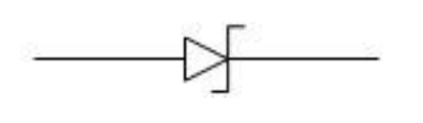

Figure: Zener Diode Symbol

The Zener diode has a breakdown voltage range between 2 and 200 volts and can operate in three main regions: forward, leakage, and breakdown. The I-V characteristic curve of the Zener diode, as illustrated in the following figure, highlights these regions:

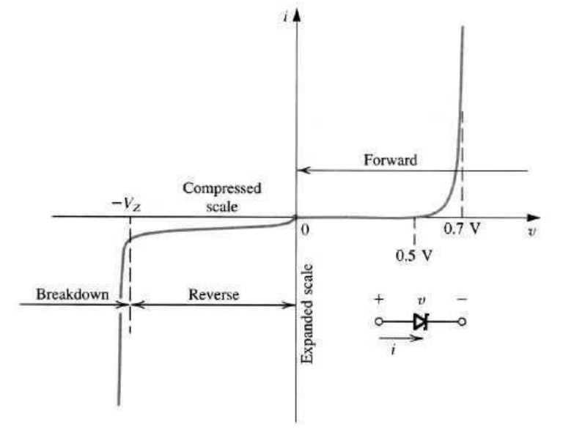

Figure: I-V Characteristics of Zener Diode

* In the forward region, it behaves like a normal diode.
* In the leakage region (between zero and breakdown voltage), it exhibits minimal reverse saturation current.
* In the breakdown region, the current increases sharply with minimal voltage change, and the voltage remains nearly constant, close to the breakdown voltage VZV_ZVZ​.

Two common approximations are used to represent the equivalent circuit of a Zener diode:

1. First Approximation: The Zener diode is modeled as a constant voltage source because the voltage across it stays steady, even as the current varies.

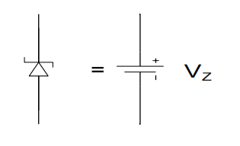

1. Second Approximation: A more refined model includes a Zener resistance in series with an ideal voltage source to account for the small internal resistance of the diode.

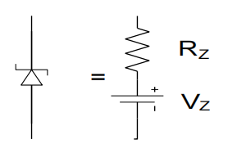

**Circuit Diagram:**

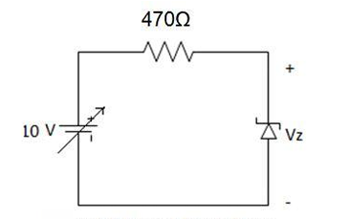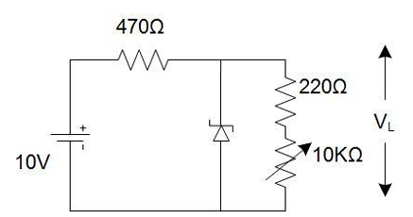

**Figure: Reverse Biased Zener Characteristics Figure: Load Regulation**

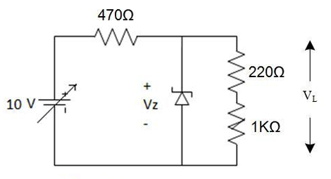

**Figure: Line Regulation**

**Experimental Procedure:**

1. Firstly, we connect the circuit as shown in the first figure.

2. We vary the supply voltage from zero volt, complete the Table 3.1 in the lab manual.

3. Then we connect the circuit as shown in the second figure.

4. We keep the POT at maximum position and power up the circuit.

5. Then, we gradually decrease the POT resistance and complete the Table 3.2 in the lab manual.

6. After that we replace the POT with 1KΩ resistance, vary the supply voltage and take reading for Table 3.3 in the lab manual.

**Experimental Data Table:**

**Results:**

The experiment showed the Zener diode's efficiency at voltage, load, and line regulation. In the voltage regulation test (Table 3.1), when the input voltage increased the Zener diode maintained a consistent output voltage near to its breakdown value of 6V, even with large increase of current. This shows its capacity to maintain a constant voltage after the breakdown threshold is reached.

During the load regulation test (Table 3.2), adjusting the load resistance resulted in variations in load current, but the load voltage V(L) stayed almost constant, indicating the diode's ability to maintain stable output under changing loads. Similarly, the line regulation test (Table 3.3) showed that the Zener diode maintained a consistent output voltage of roughly 6V despite fluctuations in input voltage, demonstrating effective line regulation.

**Questions and Answers:**

**1. Plot IZ vs VZ characteristics of Zener diode for the data table 3.1. Determine the Zener breakdown voltage from the plot.**

**Ans.**

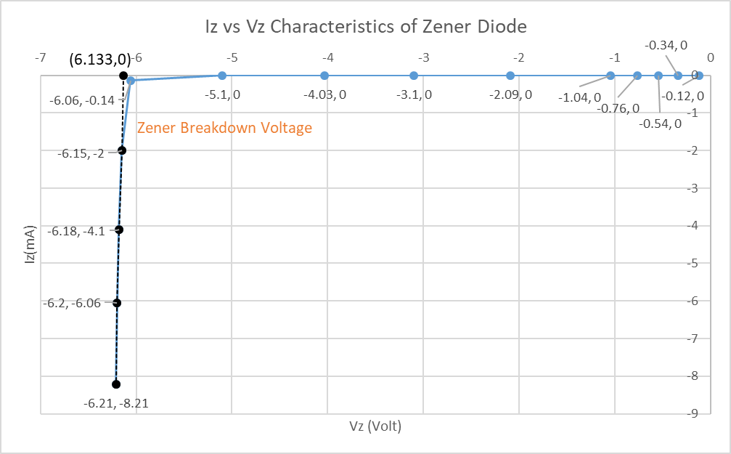

From the graph, we can conclude that the Zener Breakdown Voltage is 6.133 Volt.

**2. Plot IL vs VL for the data table 3.2. Scale [ x-axis: 0.1V/DIV, y-axis: any suitable range]. Find the Load regulation from the graph.**

**Ans.**

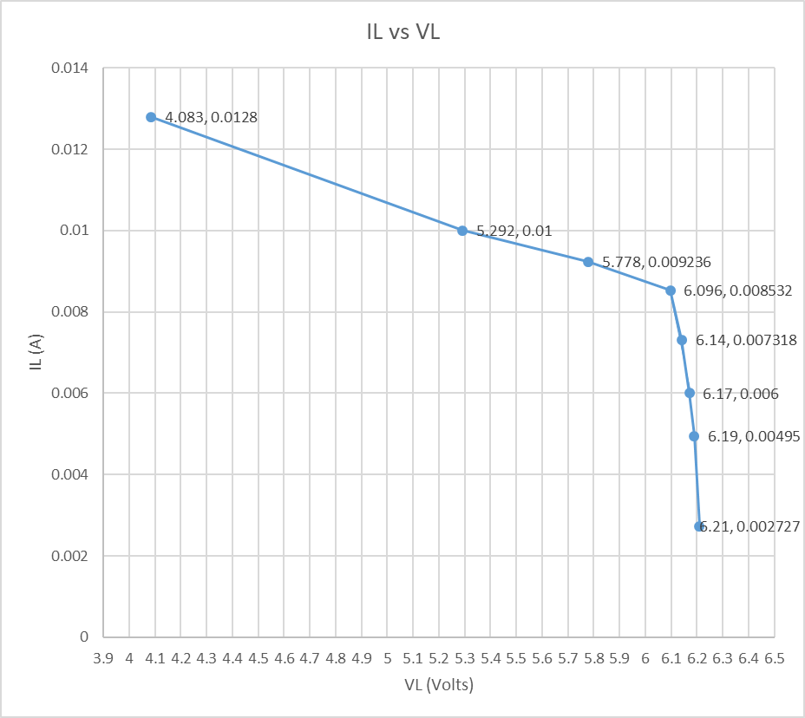

Load regulation is the change in output voltage due to a specified change in load current. From the graph, we can observe that the output voltage becomes nearly constant after the point (6.096, 0.008532) i.e. although the current IL is decreasing due to increasing RL, the voltage across the load is almost constant. Taking the two points (6.096, 0.008532) and (6.14, 0.007318) from the graph, we can calculate the load regulation.

Load Regulation = = = -36.24 ohms

**3. Plot VL vs V for the data table 3.3. Find the line regulation from graph.**

**Ans.**

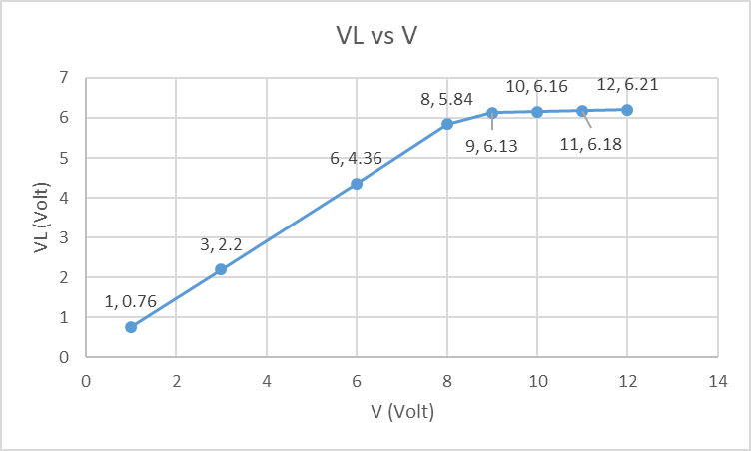

Line regulation is the change in output voltage due to a specified change in input voltage. From the graph, we can observe that the output voltage becomes nearly constant after a certain point. Taking the two points (10, 6.16) and (11, 6.18) from the graph, we can calculate the line regulation.

Line Regulation = = = 0.02

**Discussion:**

The experiment showed the Zener diode's ability to maintain a steady output voltage under fluctuating input and load circumstances, demonstrating its usefulness in voltage control applications. During the voltage regulation test, the diode successfully clamped the output to its breakdown voltage, therefore stabilizing circuits despite supply variations. The load regulation test demonstrated that the diode could keep a consistent voltage even when the load current changed, whilst the line regulation test demonstrated that it could maintain a constant output despite variable input voltages. These results underline the Zener diode's importance in protecting sensitive electronics since it can offer consistent voltage stability in power supply and protective circuits.

**Simulation:**

